SPECIFICATION OF A BANK CUSTOMER MANAGEMENT SUBSYSTEM

Introduction
The Beijing Banking Corporation (BBC) is currently undergoing the redevelopment of its computer systems using object-oriented technologies and a client/server architecture. A common component of many of the current systems is the need to create, update and view customer information. A customer is defined as anyone that has a relationship with BBC.
For the new bank system, this functionality will be provided by one (and only one) subsystem - the Customer Management Subsystem (CMS). The following sections describe the requirements for this subsystem.

Summary of System Functions
The main functions provided by the subsystem are as follows:
- Creating Customers. This function allows the user to enter information on new bank customers. To achieve this, the user enters the customer details. The system then performs qualification checks on the customer, and the information is then stored.
- Updating Customers. This function allows the user to update the information on existing customers. To achieve this, the user is able to search for and display customer information, select the required customer and change the information. The system then re-performs the qualification checks on the customer, and the changed information is then stored.
- Viewing Customers. This function allows the user to search for and display customer information.
The customer information will be stored in the existing CIF Database running on an IBM mainframe. This database also contains blacklist and bankruptcy records which will referenced during the qualification process. In addition, existing customer account records stored in the existing Accounts Database, running on an AS/400 will be reference during qualification. As a result of the qualification process, various information will be deduced or captured from the user. These data will be stored in a new database to be created on a Sun SparcStation.
The CMS client software will be Windows 95 applications running on Pentium PCs and communicating with the databases using ODBC.

Use Case Model Global View
Based on the requirements described above, use case analysis has been performed, and the actors and use cases that have been identified for the subsystem shown in following global view diagram:

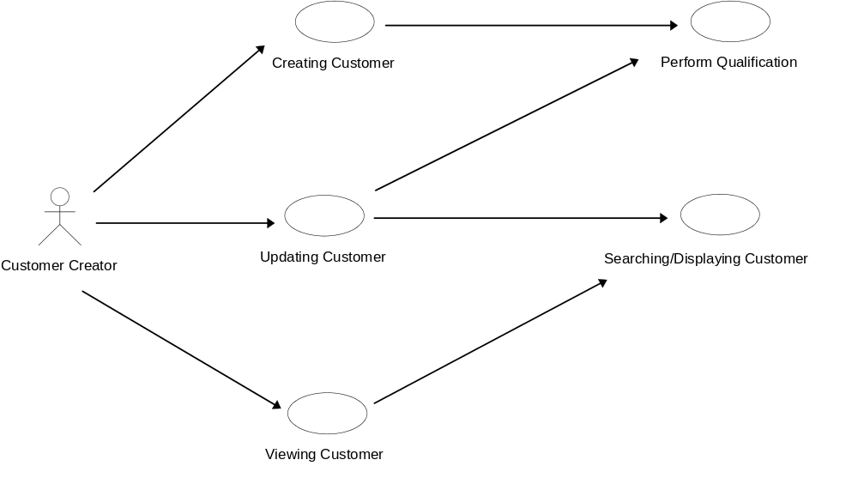

Use Case Descriptions
The requirements for each of the use cases shown in global view above are specified in the following subsections.

Creating Customer
The standard flow of events for this use case and any exceptions are described below.

Standard Flow
- To initiate the use case, the Customer Creator selects the Create Customer option from the CMS Main Menu.
- The Customer Details Screen is then displayed and enabled for data entry.
- The Customer Creator then enters the information into the screen. When all the information has been entered, the user presses the Save button.
- The system then checks the CIF database to determine whether a customer with the same Id already exists. The following will then occur:
  - If a customer already exists with the same Id then an appropriate message is displayed in a Message Box .Control is then returned to the Customer Details Screen so that the Id can be corrected by the user etc.
  - If the customer does not already exist, then the system will proceed to arrange for the qualification of the customer, and the storage of the customer in the CIF database as follows:
    - The entered data will be read from the Customer Details Screen.
    - The user name (of the Customer Creator) and date will be read from the system memory.
    - The entered customer will undergo a qualification process. This is covered by use case Perform Qualification.
    - The entered customer data, the user name and the date will then be stored in the CIF database.
  - To signify that the customer has been successfully created, an appropriate message will be displayed in a Message Box.
  - Control is then returned to the Customer Details Screen so that more customers can be entered.
- When the user has completed creating customers, the Close button on the Customer Details Screen is pressed. This closes the Customer Details Screen and control is returned to CMS Main Menu.

Exceptions
The following exceptions have been identified:
- Customer Already Exists in CIF Database. This is handled by para 4 of section 4.1.1.
- Exiting Before Saving. If Close button is pressed before the customer information has been saved (ie: the Save button has not been pressed) then the user will be informed of this. The user can then choose to exit any way. Otherwise control is returned to the Customer Details Screen and the user can use the Save button in the usual way.
- Error in Reading/Saving to CIF Database. If an error is reported will trying to read or save then an appropriate message will be displayed in a Message Box. The Customer Details Screen will then be removed from the display and control will return to CMS Main Menu.

Updating Customer
The standard flow of events for this use case and any exceptions are described below.

Standard Flow
- To initiate the use case, the Customer Creator selects the Update Customer option from the CMS Main Menu.
- The user is then allowed to search for and display the customer. This is covered by use case Searching/Displaying Customer.
- The user can then change the customer data. After the user has made whatever changes are required, the Update button is pressed.
- The system will then proceed to arrange for the qualification of the customer, and the storage of the customer in the CIF database as follows:
  - The modified data will be read from the Customer Details Screen.
  - The user name (of the Customer Creator) and date will be read from the system memory.
  - The modified customer will re-undergo the qualification process. This is covered by use case Perform Qualification.
  - The modified customer data, the user name and date will then be stored in the CIF database.
- To signify that the customer has been successfully stored, an appropriate message will be displayed in a Message Box.
- The Customer Details Screen is then removed from the display.
- Control is then returned to the Customer List Screen for Display or the Customer Search Screen so that another customer can be found/selected (see use case Searching/Displaying Customer).

Exceptions
The following exceptions have been identified:
- Illegal Changes to Data Items. To prevent customer name and other critical data items from being updated, their data entry fields on the Customer Details Screen will be disabled. This is achieved when the data is displayed in use case Searching/Displaying Customer.
- Error in Saving to CIF Database. If an error is reported while saving then an appropriate message will be display in a Message Box. The Customer Search Screen, Customer List Screen for Display and Customer Details Screen are then removed from the screen. Control then returns to the CMS Main Menu.

Perform Qualification
This abstract use case is used to perform checks on the customer to see if he/she falls under any of the following :
- bankrupt/litigation (with breakdown by category);
- blacklist;
- has excesses/arrears;
- is a classified account (ie: customer is a VIP);
- has excessive spending pattern.
The standard flow of events for this use case and any exceptions are described below.

Standard Flow
- The use case starts when another use case requires a customer to be qualified.
- The Qualify Customer Screen is displayed. The customer name and Id are passed to the use case (when the use case is called) and are displayed on the Qualify Customer Screen.
- Then the system will attempt to retrieve from the CIF database any Bankruptcy List or Blacklist records that match this customer’s name or Id.
- The system then retrieves from the existing Account database (running on the AS/400) the current status of the customer’s Current Account, FITAS Account, Loan Account and Credit Card Account.
- The system then determines and processes the bankruptcy status, litigation status and blacklist status of the customer as follows:
  - The bankruptcy status is determined by reading/assessing the bankruptcy records, and then the status is displayed on the Qualify Customer Screen .In certain circumstances when multiple records are found, no status can be determined. In such cases, the bankruptcy records are displayed on the Qualify Customer Screen. The user can then manually select the bankruptcy status and then press the Save button to record the selection.
  - The litigation status is determined by reading/assessing the bankruptcy records, and then the status is displayed on the Qualify Customer Screen. In certain circumstances when multiple records are found, no status can be determined. In such cases, the bankruptcy records are displayed on the Qualify Customer Screen. The user can then manually select the litigation status and the press the Save button to record the selection.
  - The blacklist status is determined by reading/assessing the blacklist records, and then the status is displayed on the Qualify Customer Screen. In certain circumstances when multiple records are found, no status can be determined. In such cases, the blacklist records are displayed on the Qualify Customer Screen. The user can then manually select the blacklist status and the press the Save button to record the selection.
- The system then determines the Excess/Arrears status of the customer by reading and processing various details of the customer’s Current Account, FITAS Account and Loan Account. The status is then displayed on the Qualify Customer Screen.
- The system then determines the Excessive Spending status of the customer by reading and processing various details from the customer’s Credit Card Account.
- The system then determines whether the customer accounts are Classified by reading the appropriate attribute of the customer data. The status is then displayed on the Qualify Customer Screen.
- When the user has finished viewing the Qualify Customer Screen, the Accept button is pressed. This causes the system to store the qualification data in the CIF database.
- The Qualify Customer Screen is then removed from the screen and control returns to the caller of the use case.

Exceptions
The following exceptions have been identified:
- Error in Reading/Saving to the CIF, Account or Qualification Databases. If an error is reported while reading/saving then an appropriate message will be displayed in a Message Box. The Qualify Customer Screen is then removed from the screen and control returns to the caller of the use case.

Searching/Displaying Customer
This abstract use case is used to search for and display the details of a particular customer by specifying one of the following:
- customer name (full / partial);
- id number;
- account number.
The standard flow of events for this use case and any exceptions are described below.

Standard Flow
- This use case starts when another use case requires to search for and display customer information.
- The Customer Search Screen is then displayed.
- The user enters the data specifying the customer to be displayed, and then presses the Accept button.
- The system then attempts to find the customer in the CIF database If the customer is found (ie: there is an exact match) then the customer details are read and stored in memory.
- If there is no exact match then:
  - An appropriate message is displayed in a Message Box.
  - The system then attempts to find a list of customers that closely match the user’s request. The resulting names retrieved (along with CIF number and Id) are stored in memory.
  - The system then displays the list of names in a Customer List Screen for Display.
  - The user then selects a customer to be displayed and presses the Select button. As a result, the system retrieves the selected customer for display from the CIF database.
- The system then displays the selected customer on the Customer Details Screen.
- If the use case was not called from Updating Customer, then to ensure that the data can not be changed by the user (only viewed) the data entry fields of Customer Details Screen will be disabled.
- When the user has completed viewing the customer, the Close button on the Customer Details Screen is pressed. This closes the Customer Details Screen and control is returned to the Customer List Screen for Display or the Customer Search Screen.

Exceptions
The following exceptions have been identified:
- Customer Not Found. This is handled by para 5.
- No Nearest Name Match. If there is no nearest name match then the Customer Controller will display an appropriate message in a Message Box and control will return to the Customer Search Screen.
- Terminate Customer Selection. To terminate selecting customers from the retrieved customer list the user presses the Close button. As a result, the Customer List Screen for Display is removed from the display and control returns to the Customer Search Screen.
- Terminate Customer Search. To terminate searching for customers the user presses the Close button. As a result, the Customer Search Screen is removed from the display and control returns to the calling use case.
- Error in Reading from CIF Database. If an error is reported when reading then an appropriate message will be displayed in a Message Box. The Customer Search Screen, Customer List Screen for Display and Customer Details Screen are then removed from the screen and control returns to the calling use case.

Viewing Customer
The standard flow of events for this use case and any exceptions are described below.

Standard Flow
- To initiate the use case, the Customer Creator selects the View Customer option from the CMS Main Menu.
- The user is then allowed to search for and display the customer. This is covered by use case Searching/Displaying Customer.
- When use case Searching/Displaying Customer is called, parameters are passed to indicate that the customer data can not be changed (ie: the display should be disabled).
- When use case Searching/Displaying Customer control returns to the CMS Main Menu.

Exceptions
No exceptions were identified.

